**Title (Font: Arial or Helvetica, 13.5 pt, SmallCaps, bold)**

**Author Name,1* Author Name1,2 and Author Name2 (Font: Arial or Helvetica, 10.5 pt, bold)**

*1Affiliation, Address, Town, Country and 2Affiliation, Address, Town, Country. * Correspondence to: Email address for.fun@home.ono (Font: Arial or Helvetica, 9.5 pt, italics)*

**ABSTRACT**

**Type a short abstract here (2-3 sentences). (Font: Times or Times New Roman, 10 pt, bold)**

**INTRODUCTION, RESULTS AND DISCUSSION, CONCLUSION**

(Font: Times or Times New Roman, 10 pt). I think it is agreed by all Parties, that this prodigious number of Chil­dren, in the Arms, or on the Backs, or at the heels of their Mothers, and frequently of their Fathers, is in the present deplorable state of the Kingdom, a very great additional grievance; and therefore whoever could find out a fair, cheap and easy method of making these Children sound and useful Members of the common-wealth would deserve so well of the public, as to have his Statue set up for a preserver of the Nation.

I do therefore humbly offer it to public consideration, that of the hundred and twenty thousand Children, already computed, twenty thousand may be reserved for Breed, whereof only one fourth part to be Males, which is more than we allow to Sheep*,* black Cattle, or Swine, and my reason is, that these Children are seldom the Fruits of Mar­riage, a Circumstance not much regarded by our Savages, therefore, one Male will be sufficient to serve four Females. That the remaining hundred thousand may at a year Old be offered in Sale to the persons of Quality, and Fortune, through the Kingdom, always advising the Mother to let them Suck plentifully in the last Month, so as to render them Plump, and Fat for a good Table. A Child will make two Dishes at an Entertainment for Friends, and when the Family dines alone, the fore or hind Quarter will make a reasonable Dish, and seasoned with a little Pepper or Salt will be very good Boiled on the fourth Day, especially in Winter.

After all I am not so violently bent upon my own Opinion, as to reject any Offer, proposed by wise Men [1], which shall be found equally Innocent, Cheap, Easy and Effectual. But before something of that kind shall be advanced in Contradiction to my Scheme, and offering a better, I desire the Author, or Authors will be pleased maturely to consider two points. First, As things now stand, how they will be able to find Food and Raiment for a hundred thousand useless Mouths and Backs. And Secondly, there being a round Million of Creatures in humane Figure, throughout this Kingdom, whose whole Subsistence put into a common Stock, would leave them in Debt two Mil­lions of Pounds Sterling adding those, who are Beggars by Profession, to the Bulk of Farmers, Cottagers and Labour­ers with their Wives and Children, who are Beggars in Ef­fect; I desire those Politicians, who dislike my Overture, and may perhaps be so bold to attempt an Answer, that they will first ask the Parents of these Mortals, whether they would not at this Day think it a great Happiness to have been sold for Food at a year Old, in the manner I prescribe, and thereby have avoided such a perpetual Scene of Misfortunes, as they have since gone through, by the oppression of Landlords, the Impossibility of paying Rent without Money or Trade, the want of common Sustenance, with neither House nor Cloaths to cover them from Inclemencies of Weather, and the most inevitable Prospect of intailing the like, or greater Miseries upon their Breed for ever.

**REFERENCES**

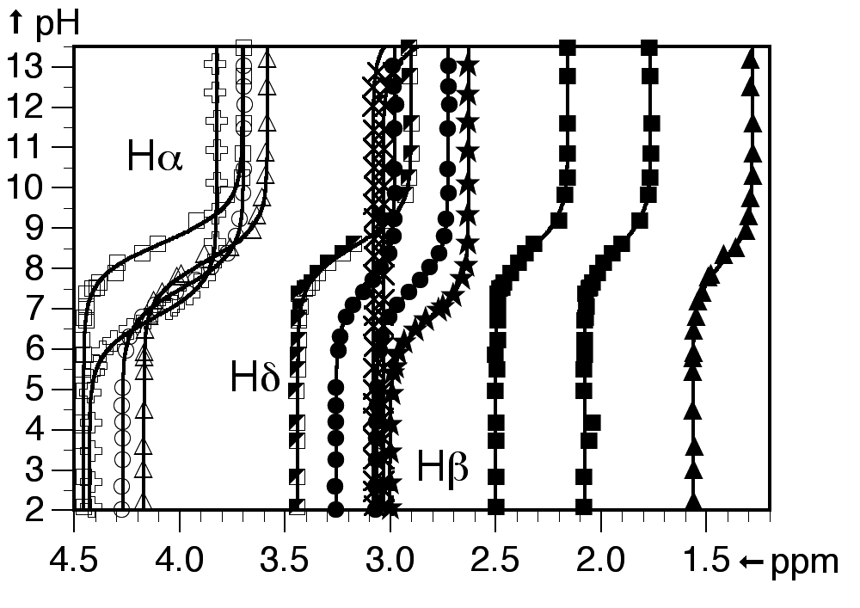

**Figure 1**. Caption. (Font: Times or Times New Roman, 9 pt)

1. Name, A., Name, B., Name, C. *J. Title Abbrev.*, **year**, *volume*, first page-last page. (Font: Times or Times New Roman, 10 pt).
2. Name, A., Name, B., Name, C. *J. Title Abbrev.*, **year**, *volume*, first page-last page. (Font: Times or Times New Roman, 10 pt).
3. Name, A., Name, B., Name, C. *J. Title Abbrev.*, **year**, *volume*, first page-last page. (Font: Times or Times New Roman, 10 pt).

**Example:**Boyer, P.L., Julias, J.G., Marquez, V.E., Hughes., S.H. *J. Mol. Biol.* **2005**, *345*, 441-450.

The abstract should be written within **one (1) page**! (any additional page (text) will be deleted). Once you have finished editing this document, please upload it.